 | 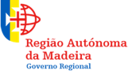 |  |  |  | 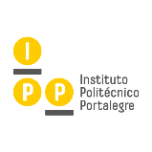 | 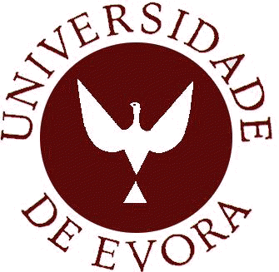

I International Congress on Sustainable Planning and Territorial Governance

Funchal - Madeira (Portugal), 4-5-6 June 2018

1st Call

The “I International Congress on Sustainable Planning and Territorial Governance”, organized in cooperation with the University of Madeira (UMa), the University of Extremadura (UEx), the Polytechnic Institute of Portalegre (IPP), and the School of Science and Technology – University of Évora (UE), will take place at Funchal - Madeira Autonomous Region (RAM) - Portugal, between 4 and 6 June 2018, at the University of Madeira (UMa), will explore recent developments, emerging issues and future challenges regarding territorial governance.
Sustainability approaches and policies are not only a desire but a necessity towards a territorial decision freedom for future generations. Those sustainability issues are even more relevant in peripheral regions, as is the case of Island territories.
In this regard, will be addressed several themes:
- Smart Cities;
- Territorial Governance and Strategies;
- Biodiversity Policies and Strategies;
- Hydraulics Planning;
- Maritime Infrastructures;
- Accessibility and Connectivity Transport Systems;
- Tourism Planning;
- Low Density Regions, Peripheral, and Insular Territories;
- Cross-Border Cooperation (CBC);
- Renewables Energies;
- Circular and Green Economy;
- Environmental Rights and Legislation.

We welcome proposals for papers on any aspect of the broad area of Sustainable Planning.
The Congress will take place at Senate Room and Amphitheaters n. º 1 to 4, at floor - 2 Campus da Penteada; intended for all students, teachers, researchers’ and all the professionals inherent to the above-mentioned themes.
The Congress work languages will be English, Portuguese and Spanish (also applied to the abstract and posters submission).
The submitted abstracts, will be reviewed by the Congress Scientific Committee, fostering the adequacy of the contents of the Congress themes. Please submit an abstract, of no more than 250 words. Posters may also be submitted. The submission process will be between December 18, 2017, and February 16, 2018 - through a specific model. Successful applicants will be informed by February 28, 2018. The deadline for full papers is April 20, 2018.
As outcomes, the Congress foresee the publication of the works in a Book of Abstracts (with ISBN). The best works will be invited to be published – as a book chapter - by the prestigious publisher “Thomson Reuters” (7th worldwide position in scientific publications) - additional payment of 300,00€. Other works will be sent for review and possible publication in Scientific Journals associated with the event – Revista Monfragüe Desarrollo Resiliente and Revista Brasileira de Planejamento e Desenvolvimento (RBPD) – no publication fees.
Early registration it should be performed until March 15, 2018. Nevertheless, registrations will continue to be accepted as later registration.
Registration fees: Early Registration – 180,00 €; Later Registration – 220,00 €; Student (subject to confirmation) – 100,00 €.
The registration will close at June 1, 2018, through the following address https://goo.gl/giaZy3.
Hope to have your presence in the Congress.

Honor Commission

Entity | Personality Name | Address | Phone/Mobile | Email
(Republic of Portugal President) | Marcelo Nuno Duarte Rebelo de Sousa | Palácio de Belém, Calçada da Ajuda, 1349-022 Lisboa, Portugal | (+351) 213 614 600 | belem@presidencia.pt
(Planning and Infrastructures Ministry) | Pedro Manuel Dias de Jesus Marques | Av. Barbosa du Bocage, nº 5 1049-039 Lisboa, Portugal | (+351) 210 426 200 | gab.infraestruturas@mpi.gov.pt
(Regional Government President) | Miguel Filipe Machado de Albuquerque | Quinta Vigia, Avenida do Infante, N.º 1 9004-547 Funchal, Portugal | (+351) 291 214 660 | gabinete.presidencia@madeira.gov.pt
(Municipality of Funchal President) | Paulo Alexandre Nascimento Cafôfo | Praça do Município, 9004-512 Funchal, Portugal | (+351) 291 211 000 | cmf@cm-funchal.pt
(OET President) | Duarte Nuno Mendes Marques | Rua da Carreira, nº 99, 9000-042 Funchal, Portugal | (+351) 291 238 596 | srmadeira@oet.pt
(OE President) | Pedro Brito Amaro Jardim Fernandes | Rua Conde Carvalhal, nº 23, 9060-011 Funchal, Portugal | (+351) 291 742 502 | madeira@madeira.oep.pt
(OASRS Madeira Delegation President) | Rui Campos Matos | Rua dos Netos, n.º 24, 9000-084 Funchal, Portugal | (+351) 291 242 050 | d.madeira@oasrs.org
(UMa Rector) | José Manuel Cunha Leal Molarinho Carmo | Colégio dos Jesuítas, Rua dos Ferreiros  9000-082 Funchal, Portugal | (+351) 291 209 401/2/3 | gabinetedareitoria@uma.pt
(UEx Rector) | Segundo Píriz Durán | Edificio Rectorado, Avda. de Elvas s/n, 06006 Badajoz, Espana | (+34) 924-289302 | uexba@unex.es
(IPP President) | Albano António de Sousa Varela e Silva | Praça do Município, 7300-110, Portalegre | (+351) 245 301 500 | geral@ipportalegre.pt
(School of Science and Technology – UÉvora – Director) | Mourad Bezzeghoud | Rua Romão Ramalho, nº59, 7000-671 Évora, Portugal | (+351) 266 745 371 | geral@ect.uevora.pt
(UÉvora Rector) | Ana Maria Costa Freitas | Largo dos Colegiais 2, 7004-516 Évora, Portugal | (+351) 266 740 800 | gabreit@uevora.pt

Organizational Commission

Cabezas, José (University of Extremadura - UEx, Spain)
Camacho, Rafael (University of Madeira - UMa, Portugal)
Castanho, Rui Alexandre (School of Science and Technology. University of Évora; and University of Extremadura - UEx, Spain)
Fernández-Pozo (University of Extremadura - UEx, Spain)
Freitas, Énio (University of Madeira - UMa, Portugal)
Freitas, Jorge (University of Madeira - UMa, Portugal)
Escórcio, Patrícia (University of Madeira - UMa, Portugal)
Lobo, Paulo (University of Madeira - UMa, Portugal)
Loures, Luís (Polytechnic Institute of Portalegre - IPP, Portugal)
Lousada, Sérgio (University of Madeira - UMa, Portugal)
Martín Gallardo, José (University of Extremadura - UEx, Spain)
Mora Aliseda, Julián (University of Extremadura - UEx, Spain)
Naranjo Gómez, José (University of Extremadura - UEx, Spain)
Pinheiro, Joaquim (University of Madeira - UMa, Portugal)
Pinto-Gomes, Carlos (University of Évora - UÉvora, Portugal)
Santos, António (University of Madeira - UMa, Portugal)

Scientific Commission

Aliseda, Ernest (University of Texas)
Batista, Teresa (University of Évora - UÉvora, Portugal)
Bedón Garzón, René (University of the Hemisphere, Ecuador)
Cabezas, José (University of Extremadura - UEx, Spain)
Castanho, Rui Alexandre (School of Science and Technology. University of Évora, Portugal; and University of Extremadura - UEx, Spain)
Catapan, Anderson (Technological and Federal University of Paraná, Brasil)
Cotella, Giancarlo (DIST - Polytechnic of Turin, Italy)
Escórcio, Patrícia (University of Madeira - UMa, Portugal)
Fernández-Jeri, Antonio (Executive Director of FISAT, Peru)
Fernández-Pozo, Luis (University of Extremadura - UEx, Spain)
Fernández-Rodríguez, Santiago (University of Extremadura - UEx, Spain)
Freitas, Jorge (University of Madeira - UMa, Portugal)
Gonçalves de Oliveira, António (Technological and Federal University of Paraná, Brasil)
Jucovsky, Vera (University of Sao Paulo, Brasil)
Jurado Almonte, José M. (University of Huelva, Spain)
Kurowska-Pysz, Joanna (University of Dabrowa Gornicza, Poland)
Lobato Torres, Ricardo (Technological and Federal University of Paraná, Brasil)
Loures, Luís (Polytechnic Institute of Portalegre - IPP, Portugal)
Lousada, Sérgio (University of Madeira - UMa, Portugal)
Luiz da Silva, Christian (Technological and Federal University of Paraná, Brasil)
Macorra, Luis (University of Extremadura - UEx, Spain)
Machín, Jorge A. Luís (Institute of Tropical Geography, Cuba)
Martín Gallardo, José (University of Extremadura - UEx, Spain)
Meza, Adrián (University of Paulo Freire, Nicaragua)
Mora Aliseda, Julián (University of Extremadura - UEx, Spain)
Naranjo Gómez, José Manuel (University of Extremadura - UEx, Spain)
Onofa, Angel (Equinoctial Technological University, Ecuador)
Pinto-Gomes, Carlos (School of Science and Technology - UÉvora (UE), Portugal)
Pozo Cabrera, Enrique (Catholic University of Cuenca, Ecuador)
Rato Nunes, José (Polytechnic Institute of Portalegre - IPP, Portugal)
Rodríguez Otero, Carlos (Physical Planning Institute, Cuba)
Santos, Pedro (School of Science and Technology. University of Évora, Portugal)
Simões, José Manuel (University of Lisbon)
Vasconcelos Vasquez, Kattia (National University of Costa Rica)
Yábar Sterling, Ana (Complutense University - UCM, Spain)

Venue

Universidade da Madeira (UMa)
Caminho da Penteada 9020-105 Funchal
Funchal-Madeira, Portugal

Collaborators

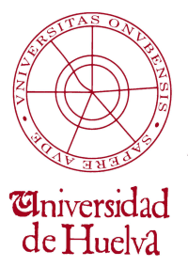 |  | 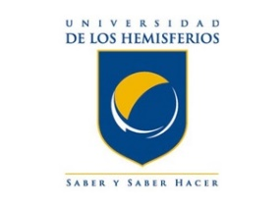 |  | 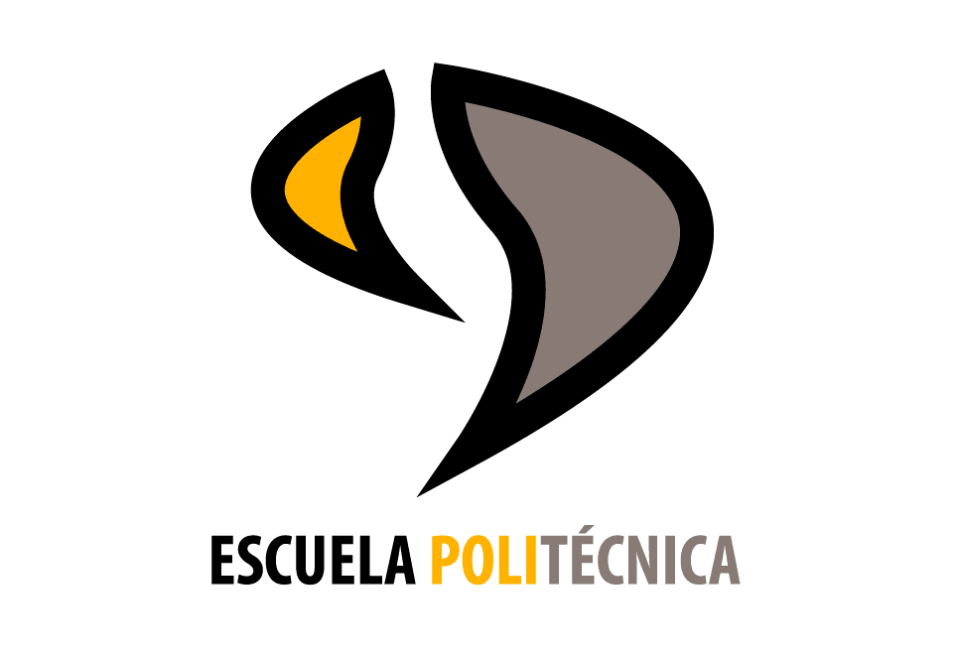

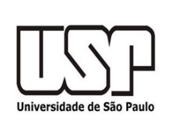 |  | 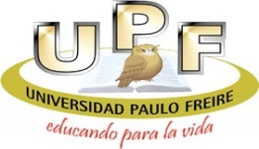 | 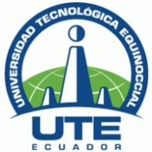

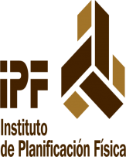 |  |  | 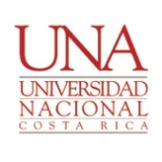 | 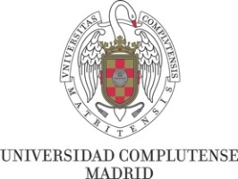
 |  | 