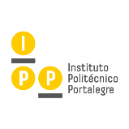

The International Congress on Sustainable Development,
Public Management and Territorial Governance

WSB University, Faculty of Applied Sciences
28-31 May 2019, Dąbrowa Górnicza, Poland
Title
(paper)
Abstract
(summarize the problem and objective of your paper and refer the method, results, conclusions, future research directions, etc.;
length: 200 - 250 words)
Key-words
(4 - 5 words)
Author(s) name
(name - surname)
If the paper is co-authored, indicate the author or authors that will be present (physical presence requires registration)
Institutional affiliation
(department, university, research centres or similar)
Position
(Prof., Dr., Post doc, PhD Student, etc.)
Postal address
(postal address of your institution)
Electronic address
(e-mail address)

